**Pre Post Trip**

***Work-flow to Use Pre Post Trip***

Use **Load Template** to set up the preference for various conditions



Repeat **Load Template** for additional instances of any template



***Preference Overview***

This preference adds pre and/or post trip times to the Vehicles Gantt. These elements allow for vehicle preparation and stand-down respectively at the beginning and end of a work day. The preference allows for

Both pre and post trip



Pre trip only



Post trip only



Additional provisions are made to allow the pre and post trip elements to be included in deadheads (pull-out/pull-in) as well as mid-day parking.



Adding pre or post trip times also affect the duties and will appear in the

Driver Gantt

You cannot use pre trip together with the **Driver Vehicle Preparation**

preference

***Templates Available from Optibus***

*Table 1-1: Templates Summary*

|  |  |  |
| --- | --- | --- |
| **Template Name** | **Purpose** | **Reference** |
| Pre\Post trip - Gen- eral | Set time preferences for both Pre Trip and Post trip. | **Pre\Post trip - Gen- eral** |
| Post trip - General | Set a time preference for Post trip only. | **Post trip - General** |
| Pre trip- General | Set a time preference for Pre trip only. | **Pre trip- General** |

Set time preferences for both Pre Trip and Post trip.

**Prerequisites:** None.

**Opening Dialog:**

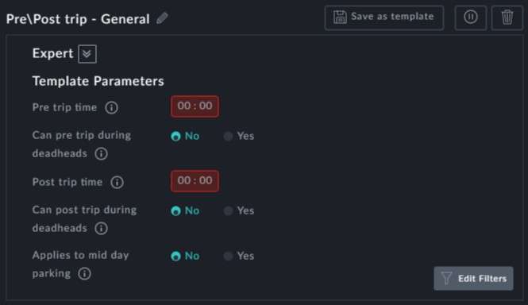

*Figure 1-1: Pre and Post Trip preferences*

**Points to note:**

**Pre trip time** and **Post trip time** are mandatory fields



**Can pre (post) trip [be included in] deadheads** Yes/No buttons: Pre trip and Post trip times may be independently included in deadheads. Typically, Pre trip time may be included in a Pull out and Post trip time may be included in a Pull in.



**Applies to mid day parking**: Setting **Applies to mid day parking** to Yes will add Post and Pre trip times respectively, upon entry to a depot and exit from the depot during the day



Use **Load Template** to create additional instances



You can create additional instances of this preference for different vehicle

types or time intervals using **Edit Filters**.

**Example:**

Here is a segment of the Vehicles Gantt for a first optimised schedule:

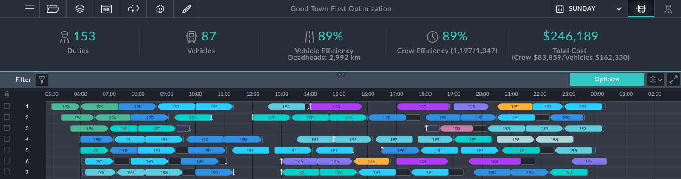

*Figure 1-2: Baseline Gantt with first optimization*

Set the pre trip and post trip times to 10 minutes and enable applies to mid day parking. Run optimization.

**Outcome:**

First here is the optimized segment shown in **Figure 1-2**:

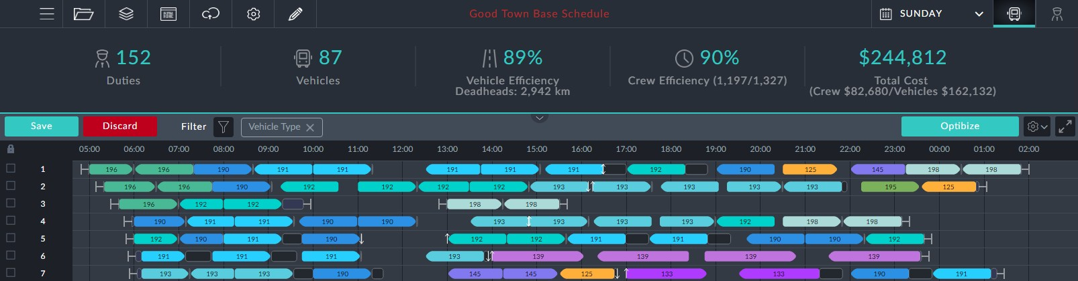

Notice that there is a pre trip element at the beginning of each vehicle block and a



post trip element at the end. Confirm the outcome by opening the information box for a Pre trip element:

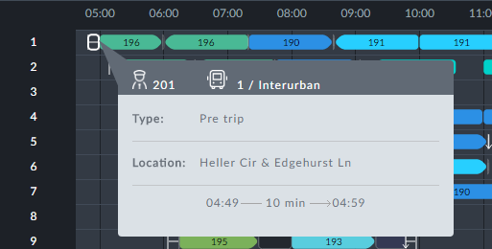

Set a time preference for Post trip only.

**Prerequisites:** None.

**Opening Dialog:**

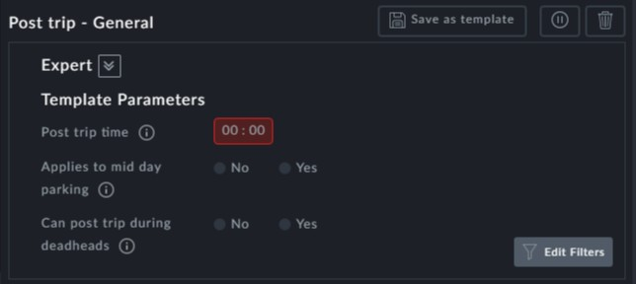

**Points to note:**

**Post trip time**: The **Post trip time** is mandatory



**Can post trip [be included in] deadheads** Yes/No buttons: Post trip time may be independently included in deadheads. Typically, Post trip time may be included in a Pull in.



**Applies to mid day parking**: Setting **Applies to mid day parking** to Yes will add Post trip times upon return to a depot during the day



Use **Load Template** to create additional instances



You can create additional instances of this preference for different vehicle

types or time intervals using **Edit Filters**.

Set a time preference for Pre trip only.

**Prerequisites:** None.

**Opening Dialog:**

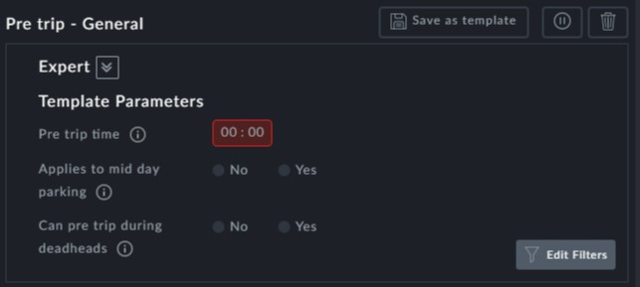

**Points to note:**

**Pre trip time**: The **Pre trip time** is mandatory



**Can pre trip [be included in] deadheads** Yes/No buttons: Pre trip time may be inde- pendently included in deadheads. Typically, Pre trip time may be included in a Pull out.



**Applies to mid day parking**: Setting **Applies to mid day parking** to Yes will add Pre trip times upon leaving a returned-to depot during the day



Use **Load Template** to create additional instances



You can create additional instances of this preference for different vehicle

types or time intervals using **Edit Filters**.